The Woodworkers Club
Recommended Tool List for Carving Class with Robert Shaw
Intro to Carving
June 5th 10-5pm

Tool Kit Options Includes:
Option #1
Pfeil carving tools and sets are Swiss made. Swiss made implies reliability and precision. pfeil is undoubtedly the finest carving tool on the market, second-to-none in terms of manufacturing quality and durability. This is an ideal selection for the beginning carver who wants a basic set of full-sized, commonly used tools.
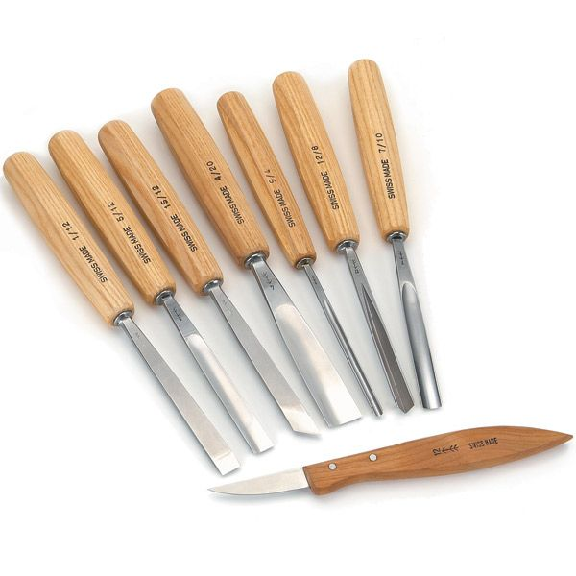
A heavy-duty, fitted tool roll, 12mm No. 1 single-bevel straight chisel, 12mm No. 1 skew cut double-bevel chisel, 12mm No. 5 gouge, 20mm No. 4 gouge, 10mm No. 7 gouge, 4mm No. 9 gouge, 8mm No. 12 V-parting and #12 chip-carving knife.

Reg. Price: $279.99
Student Price: $237.99
SKU: 05E50

Option #2
The Deluxe Palm & Knife Set pairs two popular tool sets to provide carvers a wide range of capabilities in one economic package. Set includes four razor-sharp carving knives – cutting, pelican, detail, and mini detail knives. There are also five palm tools included – 70° V-tool, #3 x 3/8" gouge, #6 x 5/16" gouge, #11 x 1/8" gouge, and a skew. Set is packaged in a wooden box for convenient and safe storage.
9-piece set combines two popular sets
Sharpened to a razor’s edge
Packaged in a wooden box for safe storage
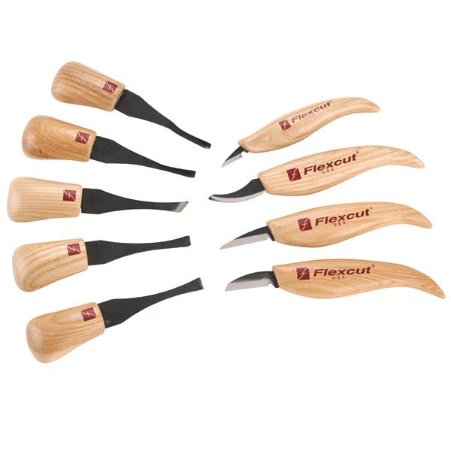
Reg. Price: $159.99
Student Price: $135.99
SKU: 854643

Option #3
Developed for hand or light mallet use, this quality assortment will please new and experienced carvers. Made in the USA of high carbon tool steel, these tools feature hardwood handles with a metal ferrule. Comfortable 6-1/4" to 6-1/2" lengths make them easy to control for detail carving. Highly recommended for the new carver doing simple or detailed work. Set includes six tools: 3/8" chisel, 3/8" skew, 3/8" bent chisel, 9/64" straight gouge, 5/16" bent gouge and 9/64" bent V-parting tool. Made of high quality tool steel, factory ground. Factory sharpened and ready for use. Overall length 6-1/8", blade length 2-1/2".
Hand or Mallet use
Hardwood Handles
Metal Ferrule
High Carbon Steel
Made in the USA

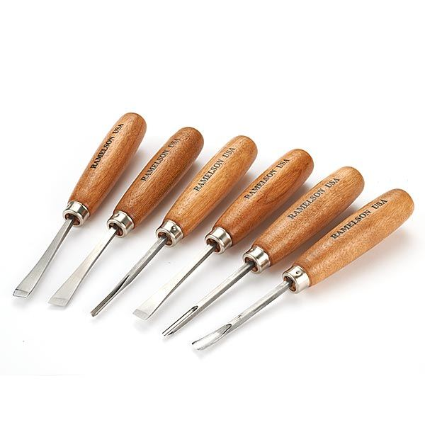
Reg. Price: $52.50
Student Price: $44.62
SKU:14I21

Sharpening:
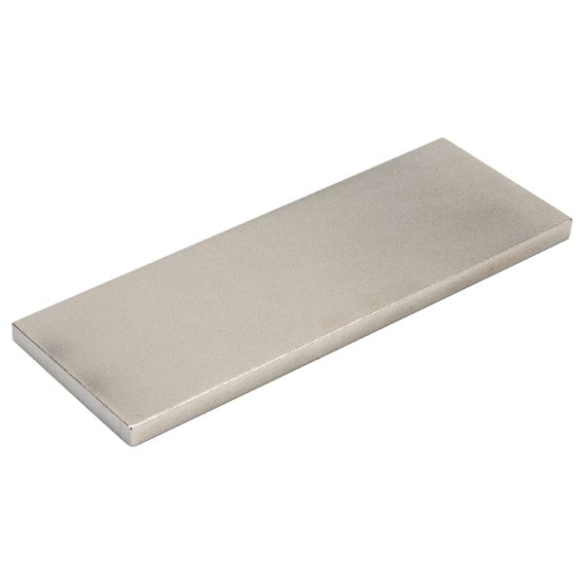
DMT Dia-Sharp, 8" x 3" Bench Stone, Extra Fine SKU 147305
Reg. Price $59.99
Student Price: $50.99

DMT Dia-Sharp, 8" x 3" Bench Stone, Extra-extra-fine SKU 411914
Reg. Price: $89.99
Student Price: $76.50

Flexcut Knife Strop
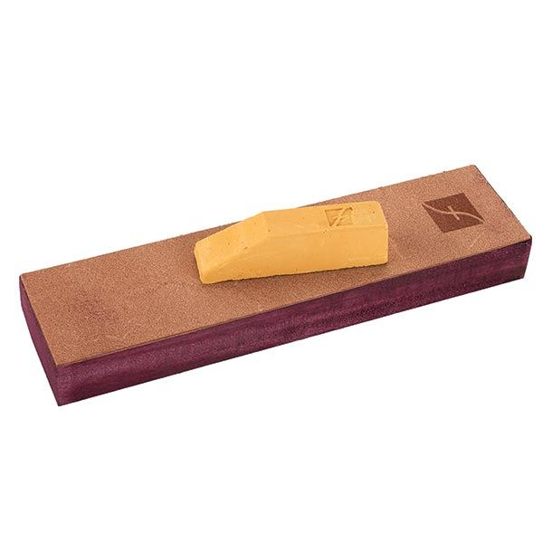
Reg. Price: $12.95
Student Price: $11.00
SKU: 159016

Flexcut Slipstrop Sharpening Kit
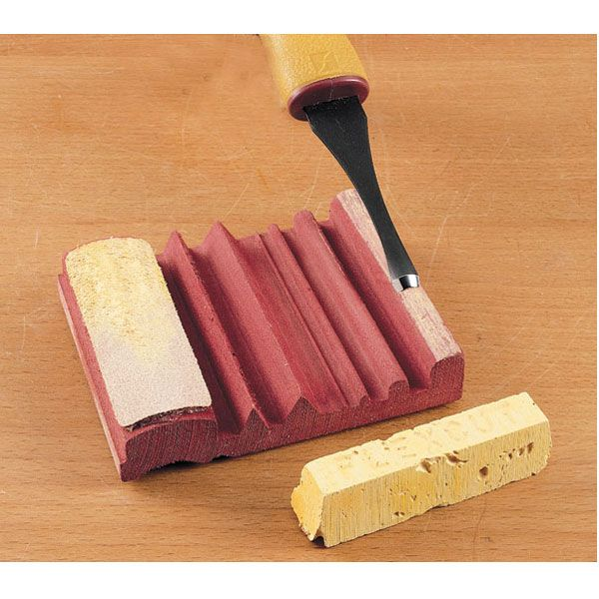
Reg. Price: $15.50
Student Price: $13.20
SKU: 143657

Safety Carving Glove
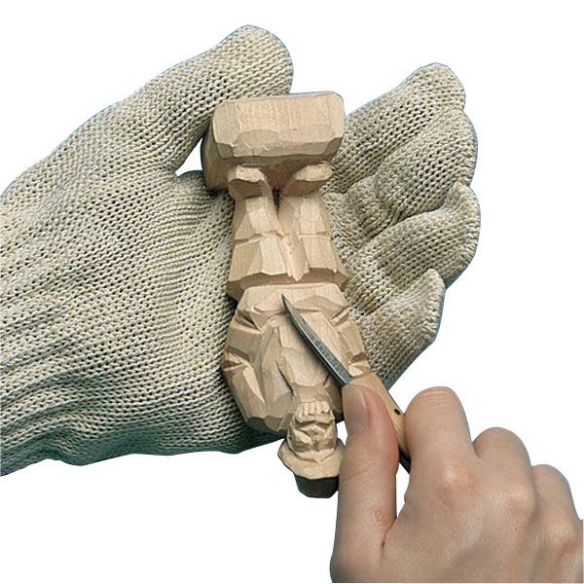
Sizes: Extra Extra Small (142886), Extra Small (06I64), Small (06I61), Medium (06I62), Large (06I63)
Reg. $26.99
Student Price: $22.95
Deeper Class Discount:
Buy any one of the tool kit options above along with the 2 DMT Diamond Sharpening Stones and receive either Flexcut Stropping kit for FREE

